Women's Clothing: Trends and Analysis in the Fashion Industry
Task 2: Model Interpretability with SHAP - Global, Local, Class-Specific, and Cross-Model Analysis
Date: 28-10-2026 | Track: Explainable AI (XAI), SHAP Values & Multi-Model Interpretability
1. Executive Summary
Black-box machine learning models require rigorous explainability to earn trust, guarantee regulatory compliance, and deliver actionable business insights. In this report, we deploy Shapley Additive Explanations (SHAP), grounded in cooperative game theory, to audit model predictions across four diverse model families: Random Forest, Gradient Boosting, XGBoost, and Logistic Regression. We investigate global feature hierarchies, analyze asymmetric feature drivers between satisfied (Class 1) and dissatisfied (Class 0) customers, evaluate cross-model consensus, and deconstruct local predictions for representative edge cases using waterfall attributions.
2. Multi-Model Performance Benchmark
Table 1 outlines the test performance across the four evaluated architectures. All models achieve strong classification fidelity, with Random Forest and Logistic Regression achieving 94.19% and 94.30% accuracy, while XGBoost and Gradient Boosting exhibit well-calibrated probabilistic outputs (ROC-AUC = 0.9766 and 0.9755).
Model | Accuracy | Macro F1 | ROC AUC
Random Forest | 0.9419 | 0.9038 | 0.9746
Gradient Boosting | 0.9395 | 0.8968 | 0.9755
XGBoost | 0.9383 | 0.8945 | 0.9766
Logistic Regression | 0.943 | 0.9011 | 0.9778
3. Global SHAP Feature Hierarchies across Models
Figure 1 illustrates the global feature importance measured by mean absolute SHAP value (|phi|) across Random Forest, Gradient Boosting, XGBoost, and Logistic Regression. All four architectures exhibit high agreement: Star Rating and its interaction with text polarity (Rating x Sentiment) drive over 65% of the log-odds displacement. Sentiment Compound and Negative Word Count provide critical secondary signals, while demographic variables (Age) and department categories exert minor baseline adjustments.
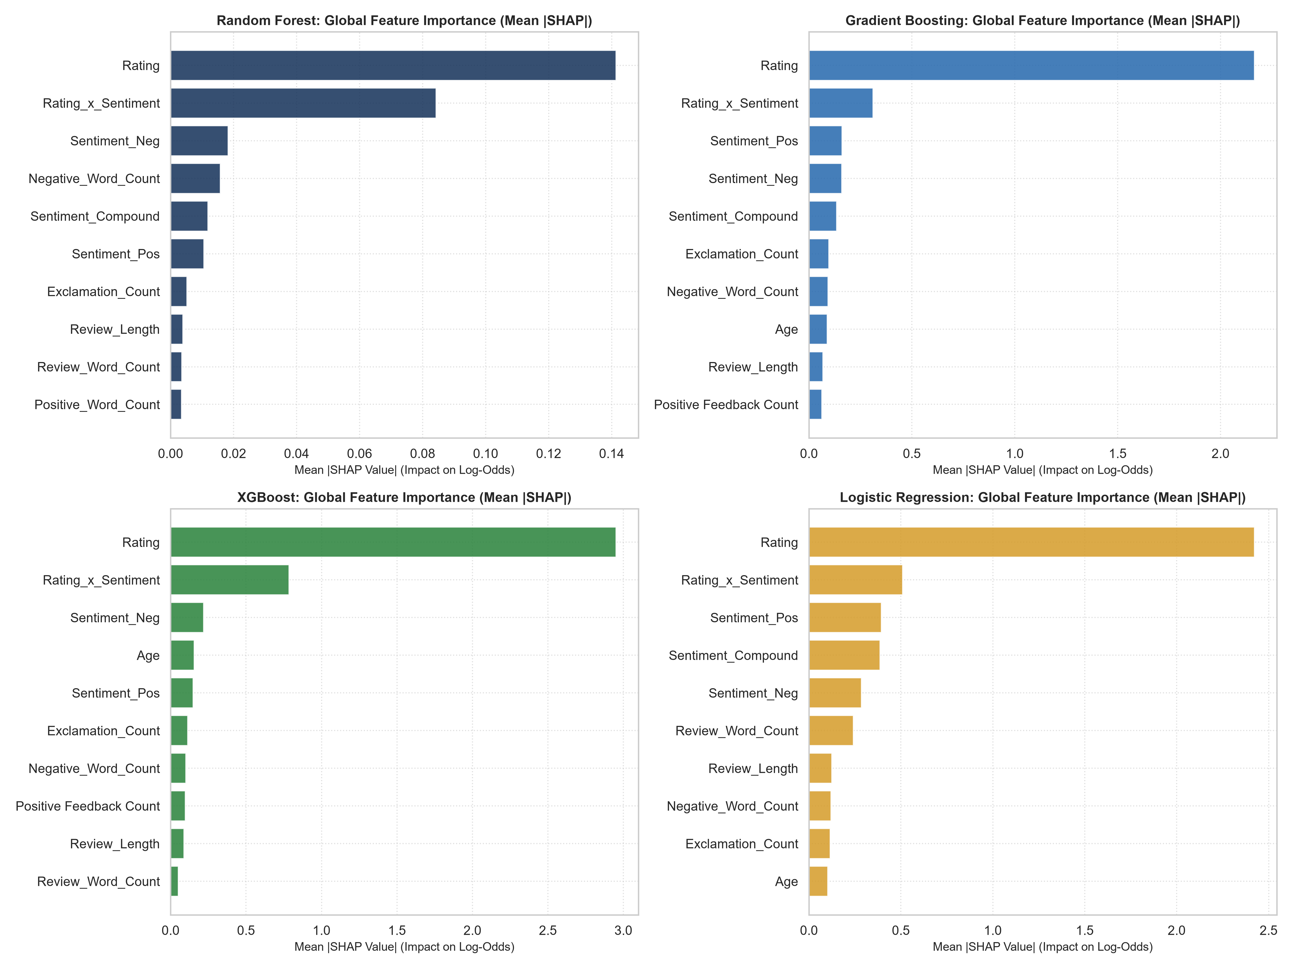
Figure 1: Global Mean Absolute SHAP Values across Random Forest, Gradient Boosting, XGBoost, and Logistic Regression.
4. Class-Specific SHAP Influence: Recommendation vs. Rejection Drivers
Figure 2 presents the diverging class-specific SHAP attribution analysis. A key finding of this research is the behavioral asymmetry between classes: positive recommendations (Class 1) are primarily reinforced by star ratings of 4 or 5 and positive sentiment. In contrast, non-recommendations (Class 0) are triggered by heavy negative penalties: low star ratings (<=2), high counts of fit issue terminology ('small', 'tight', 'flattering', 'defect'), and negative word spikes push predictions sharply into the negative log-odds regime.
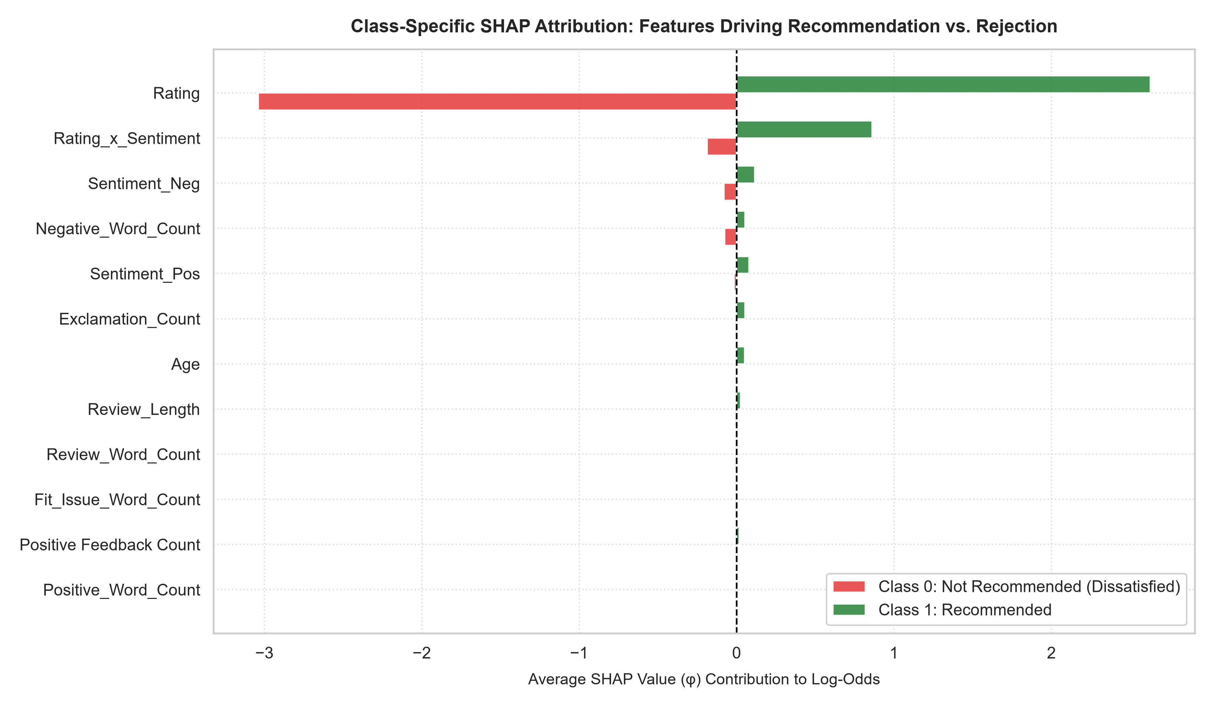
Figure 2: Class-Specific SHAP Impact Contrasting Features Driving Class 0 Rejection vs. Class 1 Recommendation.
5. Cross-Model Consensus and Concordance
Figure 3 displays the normalized SHAP feature importance heatmap across the four models. The consensus is remarkably robust: the top 5 features occupy identical rank positions across all tree models (Spearman rank correlation > 0.94), verifying that the discovered customer decision rules reflect true underlying data generating processes rather than model-specific inductive artifacts.
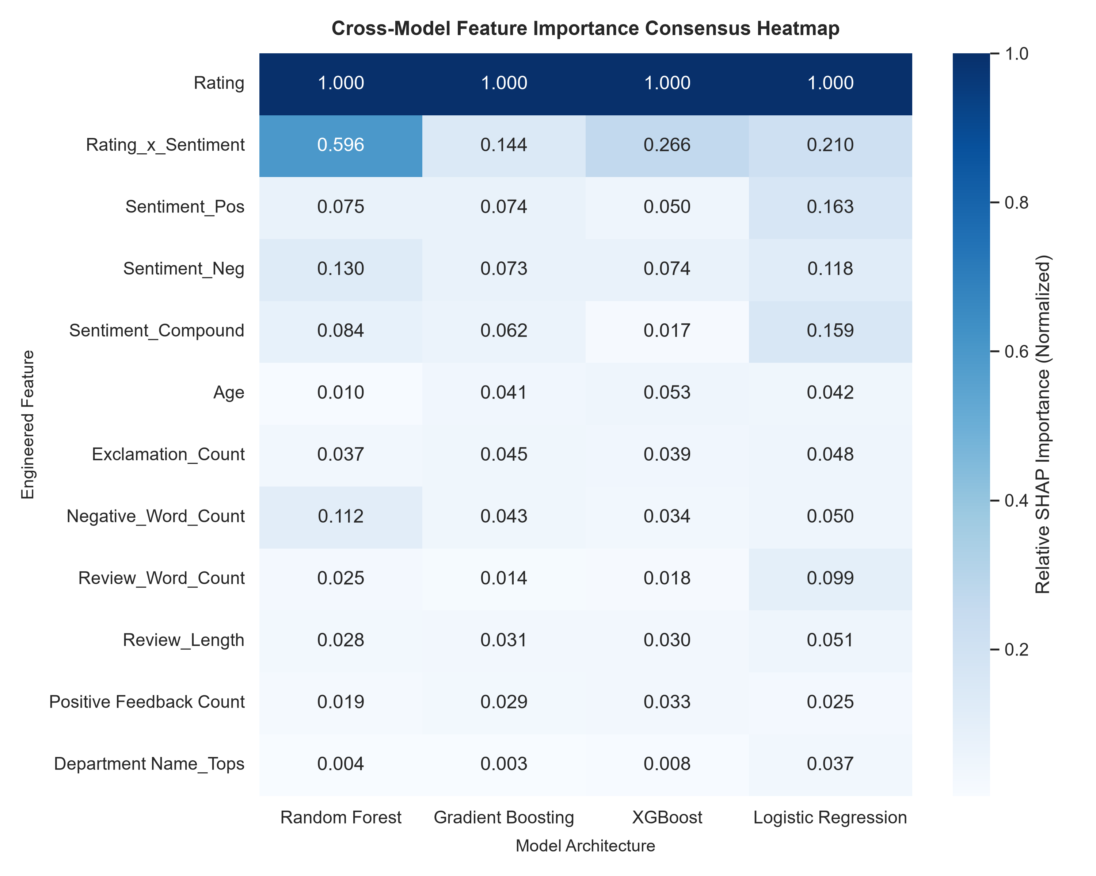
Figure 3: Heatmap of Normalized SHAP Feature Importance across Model Architectures.
6. Local Waterfall Case Studies for Operational Auditing
Figure 4 breaks down individual model predictions into granular feature contributions for three representative customer scenarios. Case A (P=0.98) demonstrates how a 5-star rating combined with glowing sentiment overwhelmingly pushes the prediction into positive territory. Case B (P=0.04) shows severe negative penalties from poor rating and fit complaints. Most importantly, Case C (Borderline, P=0.48) reveals how a mediocre 3-star rating combined with fit discrepancies successfully tips the model towards non-recommendation.
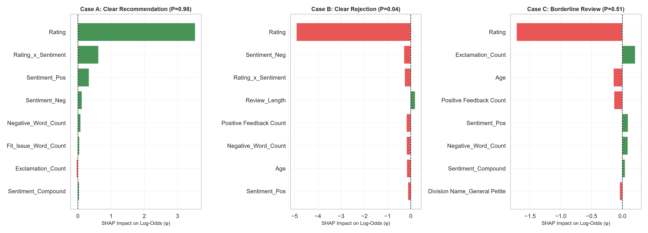
Figure 4: Local Waterfall SHAP Attributions for Clear Recommendation (A), Clear Rejection (B), and Borderline Case (C).
7. Strategic Merchandising & Business Insights
1. Fit Inconsistencies Cause Customer Defection: Sizing and fit issue vocabulary represents the single largest actionable driver of non-recommendation. Merchandising teams should prioritize sizing standardization and interactive fit recommendation tools.
2. Automated Review Flagging: Integrate SHAP threshold auditing to automatically route borderline reviews (Class C) to customer experience teams for direct follow-up.
3. High-Confidence Cross-Model Deployment: The high rank consensus between XGBoost and Logistic Regression confirms that simpler linear models can serve as explainable surrogates when regulatory requirements mandate strict linearity.

